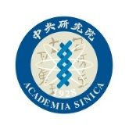

P.I./Lab Rotation Notice
Nano Science and Technology Program (NST), TIGP

Lab rotations must be completed in the first academic year prior to confirming your thesis advisor.
Students remain under the mentorship of the Student Affairs Committee Chair until your advisor is confirmed.

For any comments, concerns, or suggestions regarding the student’s performance or potential for future research, please feel free to contact the Student Affairs Committee Chair, Dr. Yu-Chieh Wen (ycwen@phys.sinica.edu.tw) or the NST Program Assistant Ms. Ju-Lien Lin (julienlin@as.edu.tw) directly.

Student Name:

Rotation Period:

P.I. Name:

Student’s Signature:

Signature from Rotation P.I.:

Date:

